Project – Part 2
Provide the college with a print management system for their student pay for print program. There will be an implementation of applications for the purpose of tracking and billing students and guest for printing services at the college. The print system will include several components; software interface for users, integration colleges ID Card Oracle database, Hotspot enterprise for web and mobile printing, ID card scanners, and hosted server infrastructure.
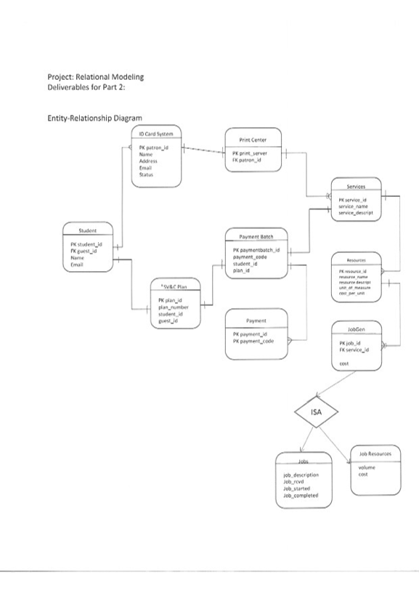

SQL Data Definition Language.
- Create a base table. Write the SQL to create a table based on one of your entities. Be sure to identify the primary key as part of your SQL syntax
create table PaymentBatch(

PaymentBatch int,
PaymentBatch_code varchar(50),
Student_id int,
plan_id int,
Primary key(PaymentBatch)
);
create table JobsGen(

job_id int,
service_id int,
primary key(job_id)

);
- Create a view. Write the SQL to create a view on the base table
Create View ShowJobsEntry(
Select * from PaymentBatch

- Show the base tables with data. Show a base table along with six rows containing data for three entities in your entity-relationship diagram. (Display each table in the form of an MS Word table.)
Select * from PaymentBatch;
TABLE with 6 rows:::
PaymentBatch | PaymentBatch_code | Student_id | Plan_id
11 | 0234Er4 | 1212 | 03
87 | 023TRW3 | 1212 | 03
315 | 0264tE4 | 1212 | 03
341 | 02TY563 | 1212 | 03
343 | 0234tyu | 1212 | 03
765 | 0234FKT | 1212 | 03
879 | 023HMK5 | 1212 | 03

SQL Data Manipulation Language (insert, update, and delete).
- Insert a row. Write a SQL query to insert a row into one of your base tables
- Update a row. Write a SQL query to change a data value in the inserted row.
- Delete a row. Write a SQL query to delete the row from your base table
update PaymentBatch set PaymentBatch_code = '0234RT#' where Student_id = '1212';
Delete from PaymentBatch where plan_id = '03'
insert into PaymentBatch values(1343, '0234Er4',1212,03);
insert into PaymentBatch values(1354, '0234tyu',1212,3432);
insert into PaymentBatch values(0315, '0264tE4',1212,3432);
update JobsGen set service_id = '325' where job_id = 1243;
insert into JobsGen values(1243,1343);
update JobsGen set service_id = '324' where job_id = 1245;

Delete from JobsGen where service_id = '03'
insert into JobsGen values(1265,1245)
insert into JobsGen values(1245,1245);

SQL Data Manipulation Language for data retrieval. For 3.1 through 3.7, write the SQL query AND show the output using the data in your base tables.
- Write a SQL query using a comparison operator (e.g., =, >, <)
select * from PaymentBatch where PaymentBatch_code='0234Er4'
PaymentBatch | PaymentBatch_code | Student_id | Plan_id
11 | 0234Er4 | 1212 | 03
- Write a SQL query using the “AND” or “OR” operator
select * from PaymentBatch where PaymentBatch_code='0234Er4' and plan_id >= 03
PaymentBatch | PaymentBatch_code | Student_id | Plan_id
11 | 0234Er4 | 1212 | 03
- Write a SQL query using the “BETWEEN” or “LIKE” operator

- select * from PaymentBatch where PaymentBatch_code Like '023%'
PaymentBatch | PaymentBatch_code | Student_id | Plan_id
11 | 0234Er4 | 1212 | 03
87 | 023TRW3 | 1212 | 03
315 | 0264tE4 | 1212 | 03
341 | 02TY563 | 1212 | 03
343 | 0234tyu | 1212 | 03
765 | 0234FKT | 1212 | 03
879 | 023HMK5 | 1212 | 03
- Write a SQL query using a built-in function
select MAX(PaymentBatch_code) from PaymentBatch
(No column name)
02TY563
- Write a SQL query using the “GROUP BY” clause
select MAX(PaymentBatch_code) from PaymentBatch group by Student_id
(No column name)
02TY563
- Write a SQL join query using two or more base tables
select student_Id , Payment_id
from Payment inner join PaymentBatch ON Payment.Payment_id = PaymentBatch.PaymentBatch

Student_id | Payment_id
1212 | 1343
1212 | 1354
1212 | 1245
1212 | 1362

- Write a SQL subquery using two or more base tables
select *
from Payment
where Payment_id <= (select max(job_Id) from JobsGen)
Payment_id | Payment_code
1343 | Service1
1245 | Service3

